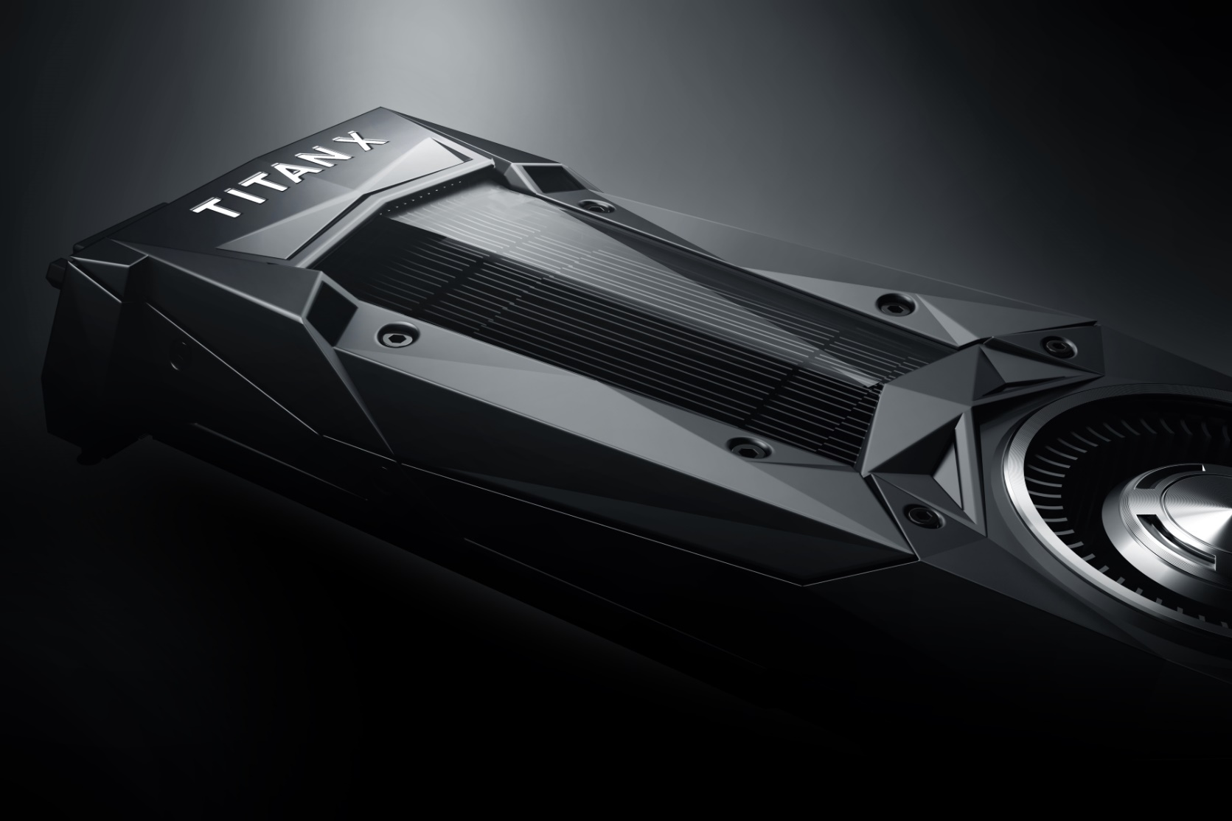

|  |
| --- |
| Coursework Report |
| By B00235610 |
|  |
| This report sets out how a given C++ application was optimized using various optimization techniques and the GPU APU CUDA. |
|  |

# Benchmark

# Profiling

# CUDA Port

# Initial Benchmarks

# Refinement

# Conclusion